**311 Call Center Tracking Data (City of Los Angeles) Analysis Report**

DSO 545 Final Project - Fall 2016

Group 6: Yu Dong, Sheng Ming, Xiaowen Zhang, Chun Yang, Xi Jiang

**Introduction**

The City of Los Angeles asked our team to develop a report that would reveal the underlying patterns of the 311 Call Center data and make improvement suggestions to City of Los Angeles based on our findings.

The goal of this report is to provide insightful geographic, demographic and time indicators for the City of LA.. This analysis is also intended to identify potential challenges and provide important context for policy and resources allocation decisions that will help shape the future of the City.

This report begins with an introduction of different data sets that our team used for the analysis, and then analyzes those data sets based on 3 dimensions: geographical, time, and request type. With each analysis followed by the insights generated from the analysis. The report concludes with action recommendations for the City of L.A.

**Part I: Data Sources**

311 Call Center Tracking data

* Data from 2011/1/1 - 2015/5/31
* Contains information about different types of service requests from calls

311 Service Request data

* Data from 2015/5/8-2016/11/17
* Contains information about different types of service requests made from different channels

2014 Census data

* Contains US population, unemployment rate, age and income information according to zip code in LA

Council District Summary Statistics

* Contains demographic information of residents living in all 15 council Districts in L.A.

Zip Code and Location data

* L.A. area zip codes and their coordinates (longitude and latitude) accordingly

**Part II: Analysis & Insights**

Geographical Analysis

* Requests Landscape

* 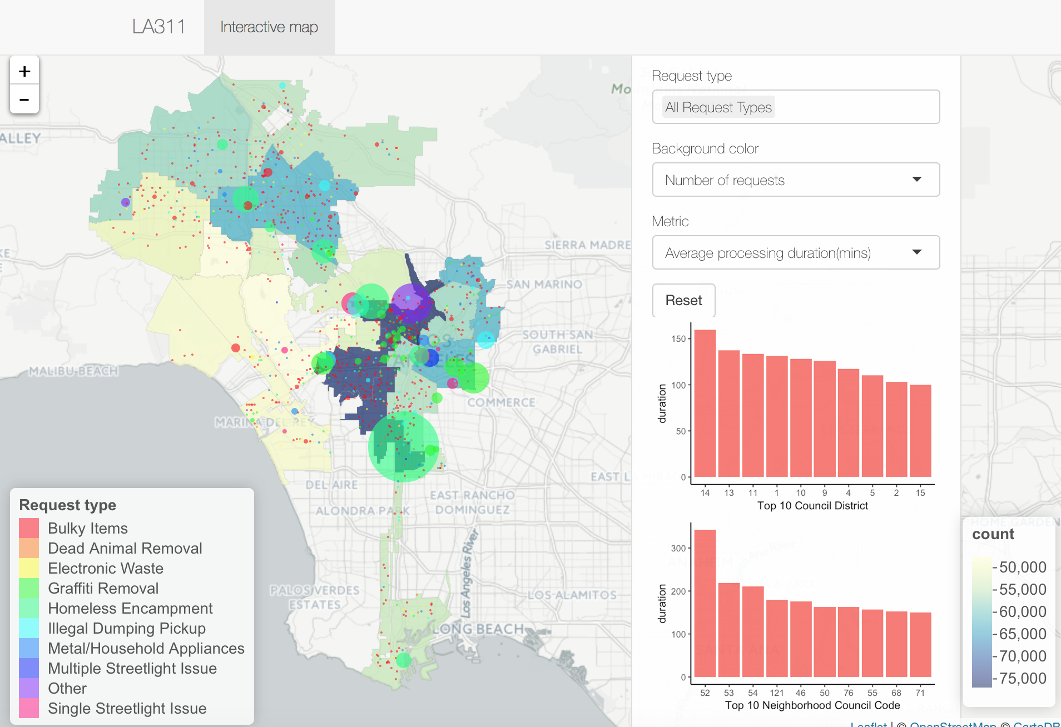We built an interactive map to observe the pattern of different types of requests by council district (CD) in a range of measurements. Colors for the council district polygons display the magnitude for the metrics you can choose from the ‘Background color’ drop-down menu. Each circle represents a record from the ‘311 Service Request’ dataset (for efficiency, we just display a sample data for 1000 observations). The size of the circle shows the relative magnitude of request processing duration. The larger the circle is, the longer time the City of L.A. spent in solving that request. Two auxiliary bar charts list top 10 council districts or neighborhood council districts in terms of the metric that can be selected from the ‘Metric’ dropdown. Furthermore, you can multi-select from all the 12 request types provided by the system data to get a deeper view within selected request types. All the background colors, circles and auxiliary bar charts can interact with request types.
* From the above screenshot, we can see that generally, the more landward CDs are, the more frequently requests occur and it seems that certain types of requests like Homeless Encampment and Other are more difficult to handle compared with other request types since their higher average processing duration.
* Combined with the top 10 number of requests and top 10 average processing duration analysis provided by the bar charts, we can see that by council district, CD13, CD10 and CD14 are kind of the areas we need to pay more attention to. By neighborhood council district (NC), we can see NC55 has the largest requests count and NC52 has a significantly longer average request processing duration than others, which the City of L.A. may need to investigate the reason behind it.

Time Based Analysis

* Distribution of Requests by Month

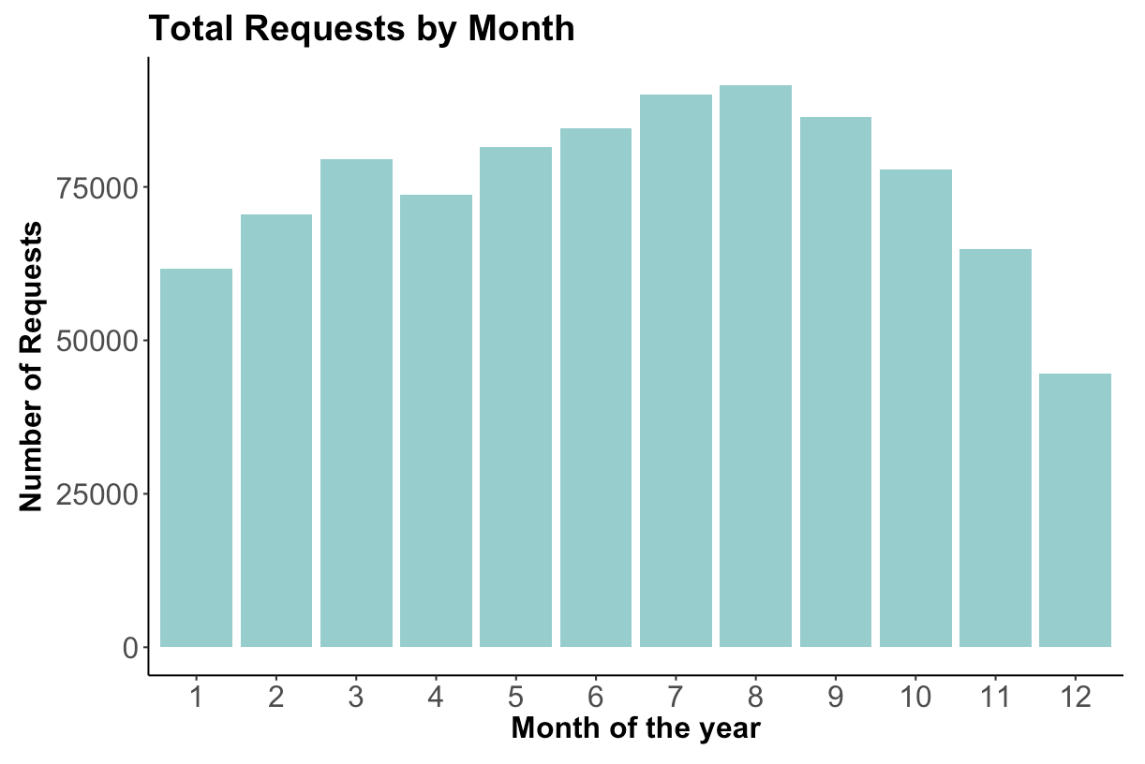

* We plotted the total number of requests created in a one-year period against month of the year. In general, more requests are made during summer months (June to September) and fewer requests are made during winter months (November to February)
* People tend to be more active in summer than in winter. More outdoor activities in summer months might be a possible cause of this situation.
* Another reason that requests in November / December are especially low might because of holidays like Thanksgiving and Christmas. Since the City of L.A. employees are most likely to be off work on holidays, it explains the reduction on number of requests created.
* Distribution of Requests by Weekday

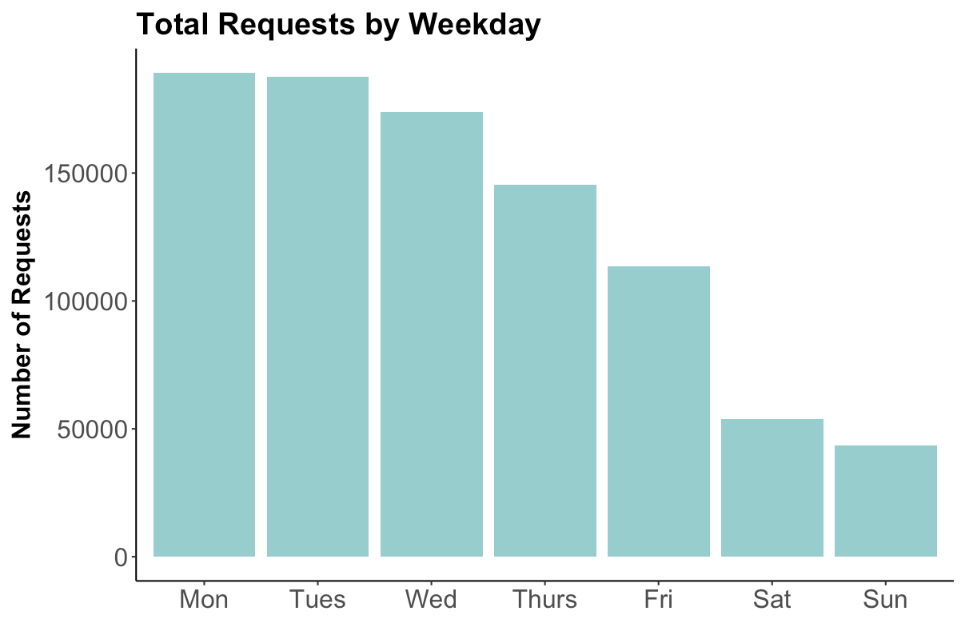

* We plotted total number of requests created in a one-year period against day of the week. More requests were made during weekdays while fewer were made during weekends. We can see a clear pattern that the requests created decreases from Monday to Sunday.
* 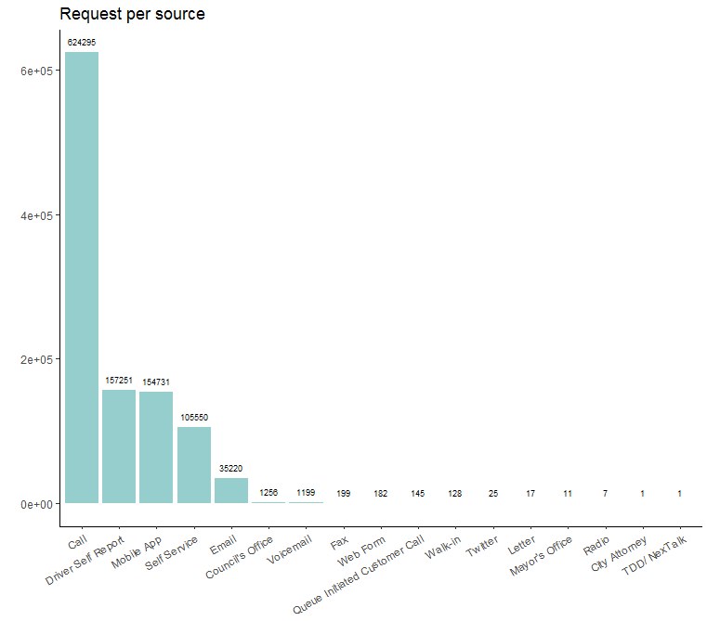It might be because that the City of L.A. has fewer people working on the weekend than on weekdays. Another explanation might be that people are more willing to submit these requests on weekdays than on weekends, when their leisure time is precious.
* Distribution of Requests by Weekday and Hour of the Day

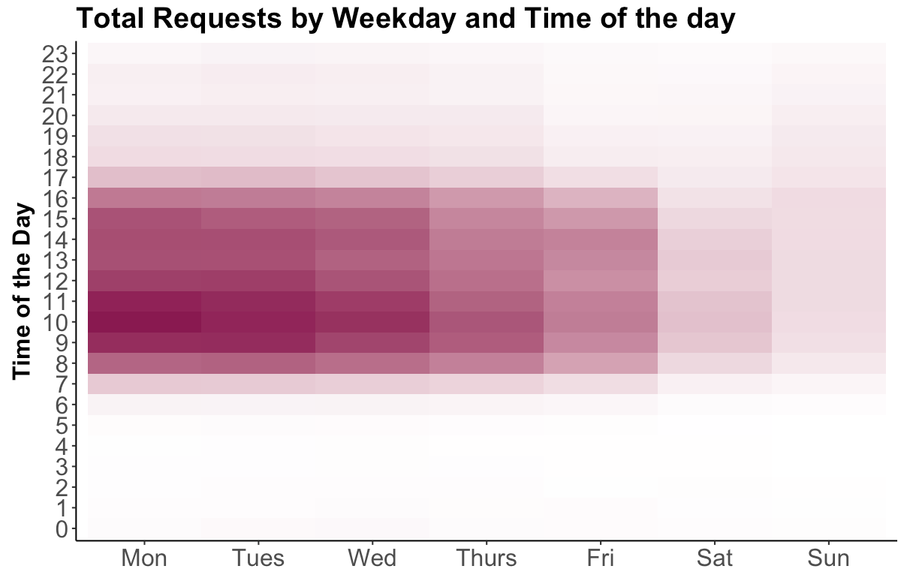

* We plotted the total number of requests created in a one-year period against time of the day and day of the week. Most of the requests are made during working hours (from 7am to 5pm) and during weekdays (Monday through Friday).
* This situation might because of people’s intention to submit requests while working, after they see something on the way to work. During weekends they might be at home resting or out of town.
* This might also be related with City of L.A. employees’ working hours. More requests are created when the City of L.A. employees are working and service fulfillment only takes place during City business hours.
* Distribution of Requests by Source
* The majority of requests are from phone calls, followed by Driver self report, Mobile App, Self service and Email.
* Requests from City Attorney and TDD are the least because of their particularity.
* Processing Time of Requests by Source

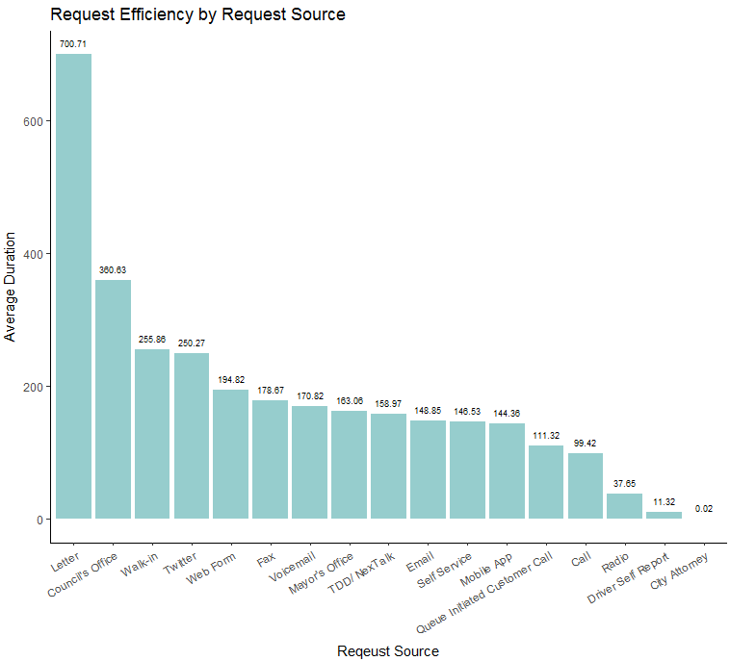

* Although most requests are from calls, the average response time is shorter than those from other sources. The performance of the 311 call center is above average.
* The most efficient source is Driver Self Report, which makes sense because it is tech-based.
* Calls are more effective than mobile apps.
* Some samples of sources are too small to conclude general results, and the efficiency depends also on request types to a great extent.

* Distribution of Requests by Source and Type

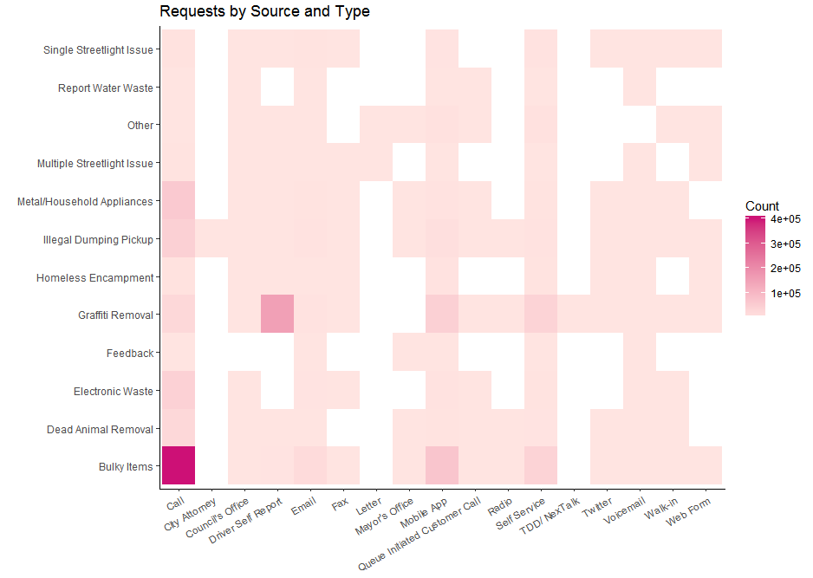

* During the time period of data, the most popular combinations of request type and source are bulky items from call, Graffiti removal from driver self report, bulky items from mobile app and metal/household appliances from call.
* Most requests are for bulky items by phone call partly because it is something urgent and cell phone is a convenient and efficient way.
* Most Graffiti Removal are requested by driver self report, which is a service tech in the field which shows this problem has already been paid attention to.
* Sources of call, mobile app, self service,voicemail, Council’s office are widely used for nearly every type of requests though the total count of the last two is small.

Efficiency Analysis

* Requests Type Efficiency Analysis

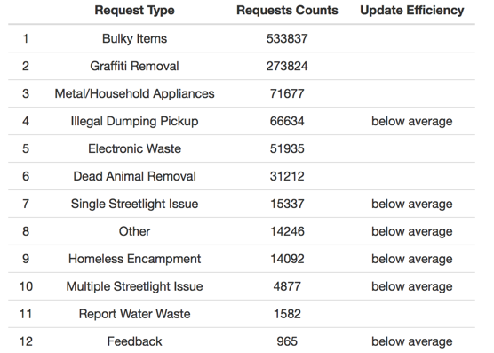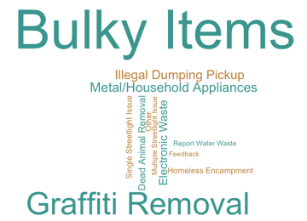

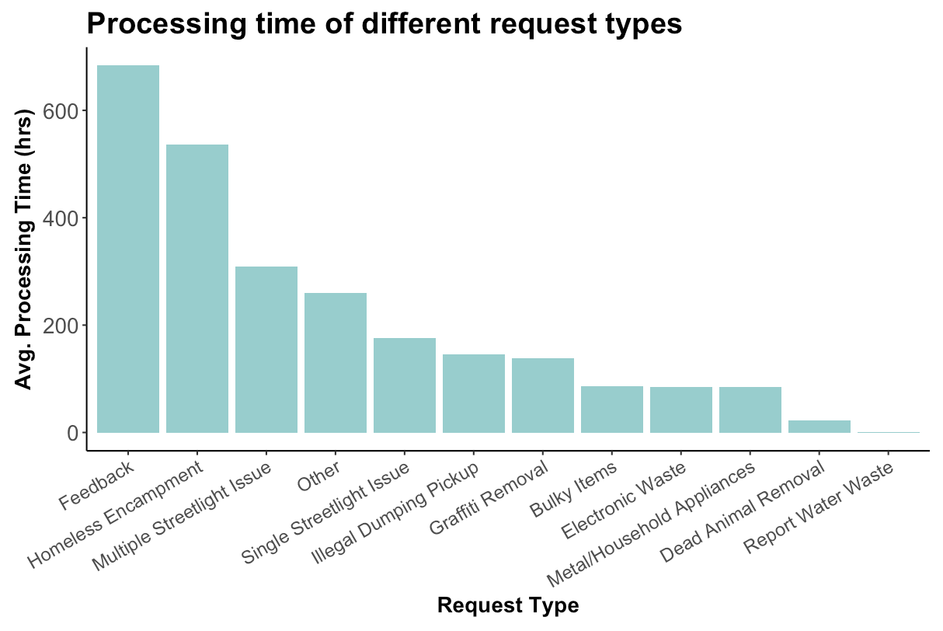

* Top 3 most frequent requests types are “Bulky Items”, “Graffiti Removal” and “Metal/Household Appliances”. In the third graph we can see that the above three request types have significantly less average processing times compared to other requests. In other words, they have above-average update efficiencies. On the other hand, those less frequent requests types (e.g. Feedback, Homeless Encampment) tend to need more time to make updates.
* This may indicate that requests treatment team is quite familiar with those frequent requests types, and have a procedure to handle them with short response period. Besides, they can improve the whole requests handling efficiency by setting efficient procedures for less-frequent requests types.
* Department Efficiency Analysis

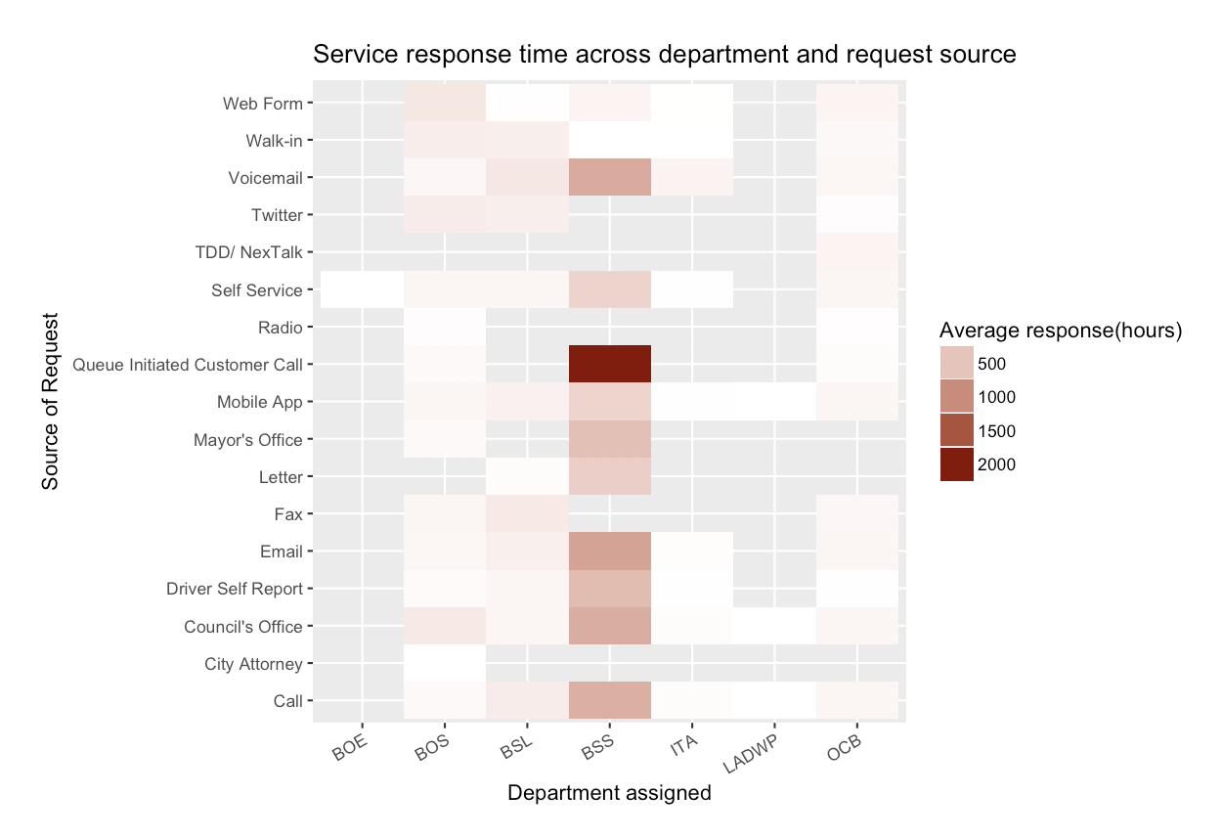

* Then we continued to see the breakdown of resolution efficiency analysis by department. We first plotted the average response time needed for each department through different request sources. Generally, the Bureau of Street Services need longest response time compared to other department, especially with request from queue initiated customer call and emails. Office of Community Beautification and Los Angeles Department of Water and Power relatively response quickly to all request sources.
* That may indicate that the workload of some departments such as Bureau of Street Services is heavier, and it may also reveal that the procedure of some request source need to be optimized.

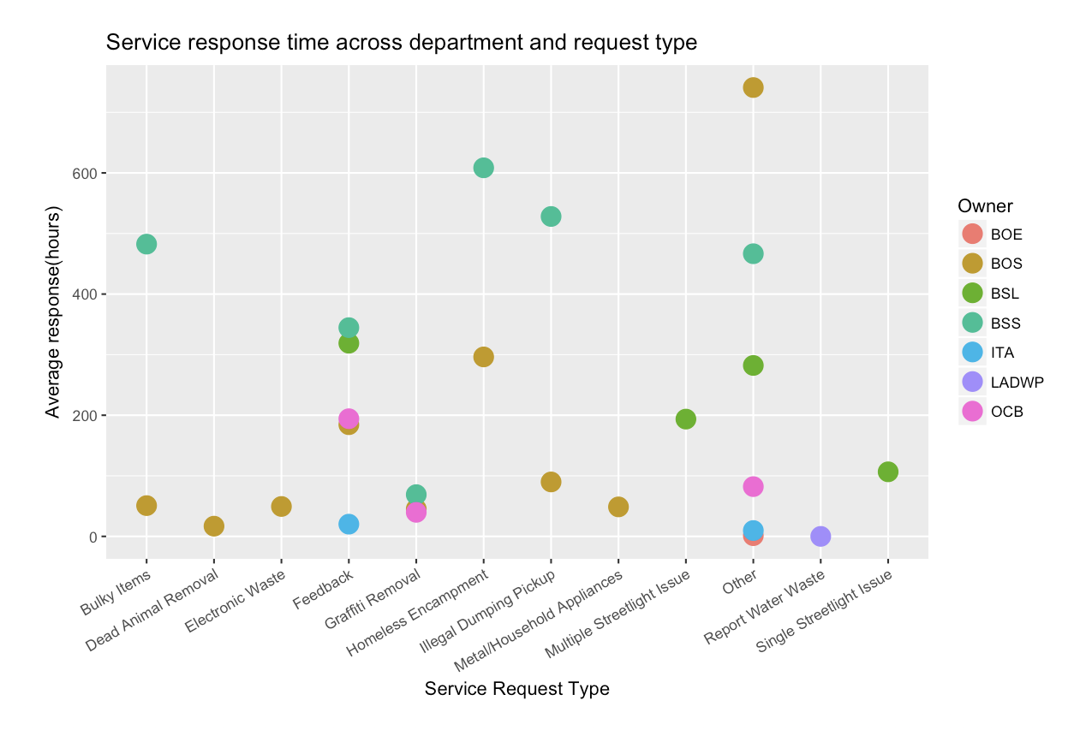

* We also explored the efficiency for each department to resolve each type of request. In this plot, we discovered the divergence for different department to solve one kind of request. For bulky items, illegal dumping pickup and homeless encampment, the Board of Supervisors shown faster reactions than Bureau of Street Services.
* The divergence might result from the different individual request situation, but may also provide possibilities to improve service efficiency.

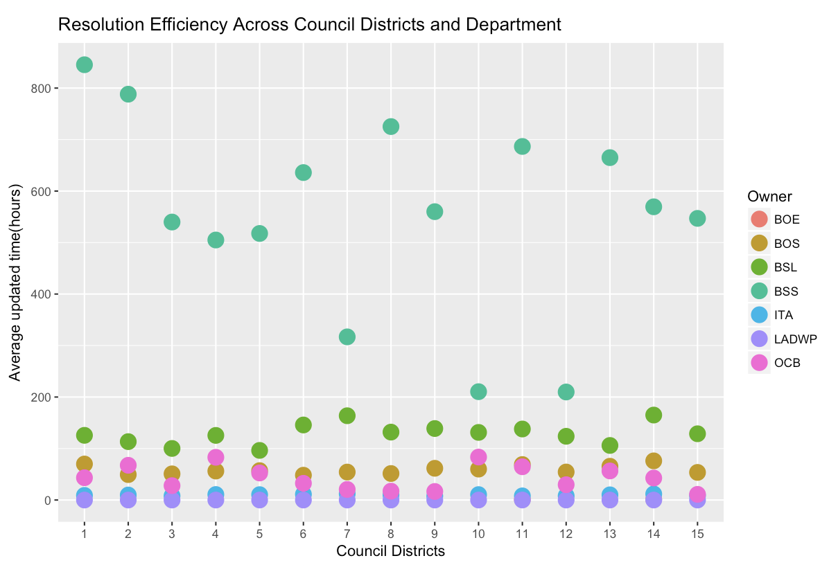

* Then we tried to looking into the connection between efficiency and council districts. The plot above shown some patterns. For Bureau of Street Services, their average response time is longer than other department. But in some area like council districts 7,10 and 12, BSS response quickly. For Bureau of Street Lighting, in council districts 7 and 14, the requests cost more time on average.
* The reason behind pattern may come from the background of resolution team in different area. Thus it provides an option for other council districts to improve their handling procedure and resolution team.

Social Analysis

* Correlation Analysis on Requests Frequency and Social Characteristics

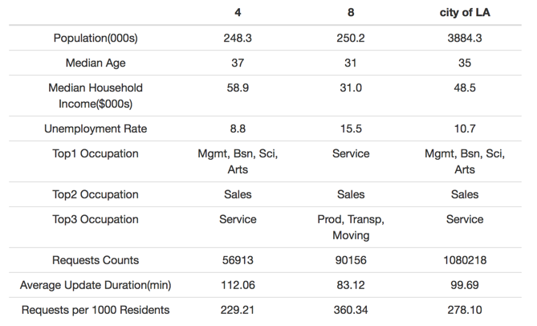

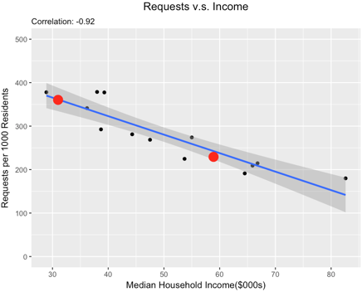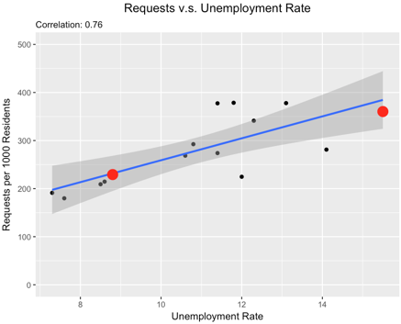

* To further explore the reason behind the differences among the number of requests per 1000 residents in different council districts, we introduced social characteristics, including regional median age, median household income, unemployment rate and top occupations to run correlation analysis. It turned out that median household income and unemployment rate could be two determinations behind frequency of requests. The higher the median household income, the lower the frequency of requests tend to be. And the unemployment rate is positively correlated with the frequency of requests.
* For example, as is shown above, although Council 4 and 8 have similar population, their requests frequency are greatly diverged. This difference could be interpreted by their great differences between the median household income and unemployment rate. It is reasonable to think about that people with higher income tend to be busier, thus are reluctant to spend time to submit a request for public affairs. Or in the other hand, a region with more employed, high-income people, tends to have fewer public problems. However, the correlation does not imply a solid causation. We need to further study on these causal interpretations.
* Besides, except those economic characteristics, other social characteristics such as the area and the population density of the region might also contribute to the requests frequency. More data is required to explore such correlation.
* Correlation Analysis on Requests Type and Social Characteristics

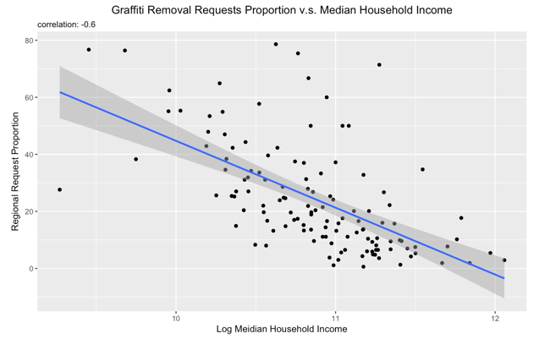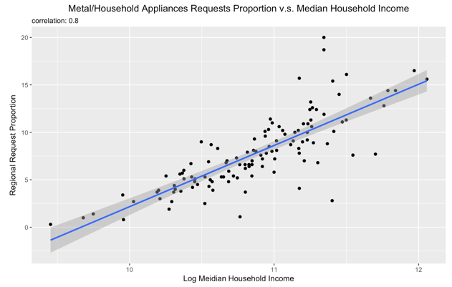

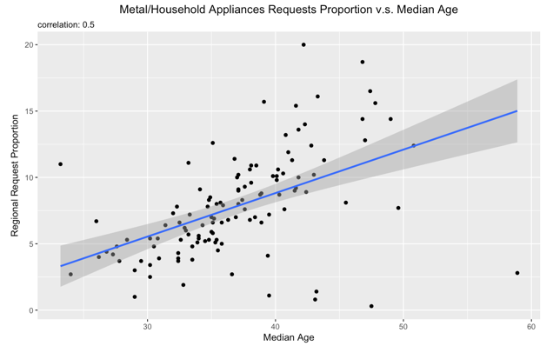

* We also explored whether the proportion of certain requests types are correlated with regional social characteristics. We found that the proportion of Graffiti Removal requests is negatively correlated with median income, while that of Metal/Household Appliances requests is positively correlation with median income and median age.
* Such correlation could be interpreted as higher-income people tend not to draw graffiti in public areas, or the higher-income community will have better community service and management thus reduce the occurrences of graffiti, or even those wealthy people just ignore them and don’t bother to report a graffiti removal request. For Metal/Household Appliances requests, wealthy people will have more such appliances, change them frequently, and are more willing to send a request to better recycle them. And elder people need more help on collecting those appliances. Still, we need to further study on these causal interpretations.

**Part III: Recommendations**

All in all, there are some recommendations we suggest based on our analysis and findings:

* While among all council districts, the top two most frequent requests are “Bulky Item” and “Graffiti removal”, different districts have distinct distribution of requests in terms of request types as can be easily noticed in the interactive map. Therefore, we suggest the City of L.A. adopting different strategies in different districts to optimize the workflow.
* Less frequent request types usually have longer processing time on average. This might be related with unfamiliarity of handling requests of those types. Therefore, we suggest that the City of L.A. divide the specialty teams into specific request type and train each group in a more function-wise way, which may help them to build up their own procedure of dealing with certain type of requests, leading to a higher overall performance.
* The more landward areas tend to receive more requests and the average processing time for the requests are also longer. This phenomenon may be caused by the different geographical properties of those areas, we suggest that The City of L.A. may deploy more specialists in the landward districts rather than the seaward districts.
* Besides the geographical factors, the City of L.A. might also want to consider reallocating resources by some higher level standards. We found that high income areas have significantly fewer number of requests compared with lower income areas. On the other hand, high unemployment areas have significantly larger number of requests in contrast to low unemployment ones. Thus, more resources allocated to low income and high unemployment areas seems like a logical next step. Furthermore, we found that residents from different age groups also show different requesting behavior like areas with more old people have larger proportion of “Metal/Household Appliances” requests on average. The City of L.A. may also take these demographic factors into account in terms of sources allocation.
* What’s more, as for the departments, the Bureau of Street Services needs longest response time compared to other department, especially with request from queue initiated customer call and emails, while Office of Community Beautification and Los Angeles Department of Water and Power response relatively quick to all request sources. This phenomenon may suggest a potential need of resources transfer among different departments.